

**PRINCE2®** 6th Edition

**(PR**ojects **IN C**ontrolled **E**nvironments)

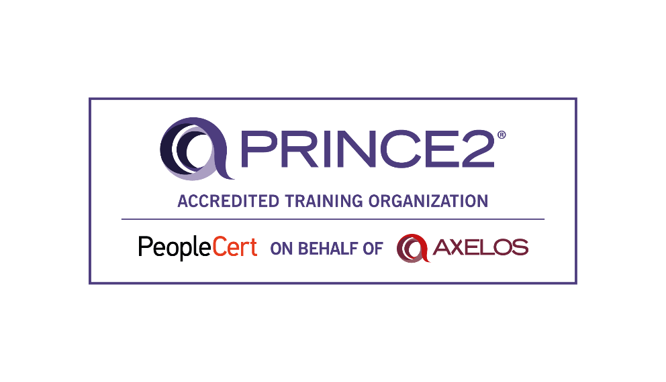

Information Pack & Application Form

PRINCE2® is a registered trademark of AXELOS Limited, used under permission of AXELOS Limited. All

rights reserved.

**PRINCE2®** 6th Edition**Definition**

**PRINCE2®** 6th Edition (an acronym for **PR**ojects **IN C**ontrolled **E**nvironments) is a process-based method for effective project management. Used widely by the UK Government, PRINCE2 is also commonly recognised and used in the private sector, both in the UK and internationally. The PRINCE2 method is in the public domain, and offers non-proprietorial best practice guidance on project management.

Key features of PRINCE2:

* Focus on business justification
* Defined organisation structure for the project management team
* Product-based planning approach
* Emphasis on dividing the project into manageable and controllable stages
* Flexibility that can be applied at a level appropriate to the project

**PRINCE2 History**

PRINCE was established in 1989 by CCTA (the Central Computer and Telecommunications Agency), since renamed to OGC (the Office of Government Commerce). In June 2010, the Office of Government Commerce Best Practice Management functions moved into the Cabinet Office.

PRINCE was originally based on PROMPT, a project management method created by Simpact Systems Ltd in 1975, and adopted by CCTA in 1979 as the standard to be used for all Government information system projects.

When PRINCE was launched in 1989, it effectively superseded PROMPT within Government projects. PRINCE remains in the public domain and copyright is retained by the Crown. PRINCE2 was published in 1996, having been contributed to by a consortium of some 150 European organisations.

**How PRINCE2 Can Benefit You or Your Organisation?**

Using PRINCE2 provides you with greater control of resources, and the ability to manage business and project risk more effectively. This will benefit:

* Individuals seeking leading project management skills and greater employment prospects
* Project managers
* Directors/executives (senior responsible owners) of projects, and Organisations

For individuals, PRINCE2 certification is a vital asset to your career as it increases employment prospects and helps you to do your job more effectively.

For organisations, PRINCE2's formal recognition of responsibilities within a project, together with its focus on what a project is to deliver (the why, when and for whom) provides your organisation's projects with:

* A common, consistent approach
* A controlled and organised start, middle and end
* Regular reviews of progress against plan
* Assurance that the project continues to have a business justification

**PRINCE2®** 6th Edition **Qualifications and Training**

We offer the following PRINCE2 training: *Prince2 Overview, PRINCE2 Foundation,* *PRINCE2 Practitioner and PRINCE2 Re-Registrations*.

**PRINCE2 Overview**

This course is aimed at delegates who require an overview of PRINCE2 project management and its methodology, and to gain an understanding of its processes and themes. The day’s course – which provides a comprehensive introduction to PRINCE2 - will cover what the method is; why use it; processes and benefits; as well as discussing and understanding the PRINCE2 themes. This is a great course to take before committing yourself to the full qualification. It does not involve any exams.

**PRINCE2® 6th Edition Foundation**

A great place to start, the PRINCE2 Foundation qualification covers the basic methodology and terminology of PRINCE2.

PRINCE2 Foundation introduces you to the PRINCE2 method enabling you to act as an informed member of the project team within a PRINCE2 environment.

Accredited by PeopleCert, this three-day training event combines theory and practice, working around a case study to establish a sound understanding of the PRINCE2 methodology.

The exam voucher price is included in the training’s price.

**Please note:** you will be required to complete pre-course work prior to yourattendance to ensure you are fully prepared for this classroom course. Whilst attending, you should also be prepared to complete evening work.

**PRINCE2® 6th Edition Practitioner**

The PRINCE2 Practitioner is suitable for those managing projects within a PRINCE2 environment.

PRINCE2 Practitioner teaches you to apply PRINCE2 to the running and managing of a project within a PRINCE2 environment.

This fully accredited two day tutor-led Practitioner event allows delegates the opportunity to consolidate the knowledge they have acquired from studying PRINCE2 at Foundation level, by discussing and practicing the practical application of these skills in a facilitated environment.

The exam voucher price is included in the training’s price.

**Please note**: Participants must achieve a pass at Foundation level beforecompleting the Practitioner examination. You will be required to complete pre-course work prior to your attendance to ensure you are fully prepared for this classroom course. Whilst attending you should also be prepared to complete evening work.

**PRINCE2® 6th Edition Foundation and Practitioner**

Accredited by the PeopleCert, this five-day Foundation and Practitioner training event combines theory and practice, working around a case study to establish a sound understanding of the PRINCE2 methodology.

This workshop is divided into two modules: Firstly, a three day Foundation course providing a solid understanding of the scope, content, terminology and processes of PRINCE2, and resulting in participants taking the Foundation examination on the final day. Secondly, a two day Practitioner course, allowing delegates the opportunity to gain a wider understanding of the application of PRINCE2 in a project context by discussing and practicing the application of these skills in a facilitated environment. This two day event provides the opportunity for participants to take the Practitioner examination.

**Please note:** You will be required to complete pre-course work prior to yourattendance to ensure you are fully prepared for this classroom course. Whilst attending you should also be prepared to complete evening work. Participants must achieve a pass at Foundation level before commencing the Practitioner examination.

**We also offer PRINCE2 Re-Registration and retakes.**

Birmingham Adult Education Service / Corporate Training Learner Agreement Form

fields marked **\*** are mandatory to generate a Unique Learner Number and Learner Record

**SECTION 1: YOUR PERSONAL DETAILS Learner Ref No:**

|  |  |
| --- | --- |
| **Preferred Pronoun**  **🞏 He 🞏 She 🞏 They** | **Date of Birth\***: |
| **Surname\*** | **Forename(s)\*** |
| **Home Address\*** | **Postcode\*** |
| **Tel. No.** (Work): | **Mobile. No:** |
| **Email address:** | |
| **Emergency Contact Forename:** | **Emergency Contact Family Name:** |
| **Relationship to You:** | **Contact Number:** |

**What is your ethnic group? Choose one option that best describes your ethnic group or background**

**White Mixed / Multiple ethnic groups Asian / Asian British**

🞎 English / Welsh / Scottish / Northern Irish / British 🞎 White and Black Caribbean 🞎 Indian

🞎 Irish 🞎 White and Black African 🞎 Pakistani

🞎 Gypsy or Irish Traveller 🞎 White and Asian 🞎 Bangladeshi

🞎 Any Other White Background 🞎 Any other Mixed / multiple ethnic background 🞎 Chinese

🞎 Any other Asian background

**Black / African / Caribbean / Black British Other ethnic group**

🞎 African 🞎 Arab

🞎 Caribbean 🞎 Any other ethnic group

🞎 Any other Black / African / Caribbean background

13.

**Your Job Title**: _______________________________________________

Directorate (please tick one):

🞏 **People** 🞏 **Place** 🞏 **Economy** 🞏 **Acivico** 🞏 **BAES** 🞏 **LEA Schools** 🞏 **Capita**

🞏 **Change & Support Services** 🞏 **Other** please state ____________________________

**SECTION 2: SUPPORT NEEDS**

|  |  |
| --- | --- |
| Please ✓and complete the appropriate boxes to help us plan for relevant support while you are on your course | |
| Would you describe yourself as having a learning difficulty or learning disability?  **If ‘Yes’ please give details** | Yes 🖵 No 🖵 |
| Would you describe yourself as having a disability?  **If ‘Yes’ please give details** | Yes 🖵 No 🖵 |

|  |  |  |
| --- | --- | --- |
| Would you hear a fire alarm in normal circumstances? | Yes 🖵 No 🖵 | Staff Use – PEEP form completed by & date |
| Do you need assistance to evacuate a building in an emergency? | Yes 🖵 No 🖵 |  |

**SECTION 3: CONFIRMATION OF EMPLOYMENT STATUS AND BENEFIT ENTITLEMENT**

|  |  |  |  |  |  |  |
| --- | --- | --- | --- | --- | --- | --- |
| **A** | **YOUR CURRENT EMPLOYMENT STATUS** | | | Please tick ✓ the box of **all statements** which apply to you | | |
| **Are you …**   * • Employed (1 - 10 hours per week); How long have you been employed? [ ] Years [ ] Months * • Employed (11 - 20 hours per week); How long have you been employed? [ ] Years [ ] Months * • Employed (21 - 30 hours per week); How long have you been employed? [ ] Years [ ] Months * • Employed (over 31 hours per week); How long have you been employed? [ ] Years [ ] Months * • Self employed; Hours per week [ ] How long have you been self employed? [ ] Years [ ] Months   🞏 Unemployed, actively looking for and ready to start work in the next 2 weeks, or already have a job and waiting to start  How long have you been unemployed? [ ] Years [ ]  🞏 In receipt of Job Seekers Allowance, including National Insurance credits only  🞏 In receipt of Employment Support Allowance in the Work Related Activity Group - ESA (WRAG) | | | | | |
| Universal Credit, and have an earned income from employment less than £338 a month (single claim) or £541 a month (joint claim) | | | | | |
| 🞏 Mandated to undertake skills training by Job Centre Plus (JCP)  🞏 Unemployed, as above, in receipt of an Income Based Benefit (as listed in Section C) and doing this course to improve my skills to gain employment. **Please complete section C**  🞏 Employed and earning less than £9.30 per hour *(proof of income must be provided).*  What is your National Insurance Number? [ ] | | | | | |
| **B** | 🞏 Unemployed, NOT looking for work and NOT ready to start work | | | | | |
| How long have you been unemployed? [ ] Years [ ] Months | | | | | |
| 🞏 Retired or not working and not collecting benefits (Economically Inactive) | | | | |  |
| How long have you been retired, not working or collecting benefits? | | | | [ ] Years [ ] Months | |
| **C** | **ARE YOU IN RECEIPT OF ONE OF THESE INCOME BASED BENEFITS** | | | Please tick ✓ which ones apply to you | | |
| 🞏 Income Support | 🞏 Income-related employment Support Allowance | | | 🞏 Housing Benefit | |
| 🞏 Universal Credit other than above | | 🞏 Asylum Support | | 🞏 Pension Credit | |
| 🞏 Working Tax Credit in my own name and my household income is less than £17,560 | | | | | |
| 🞏 Working Tax Credit in my partner’s name or joint names, our household income is less than £17,560 | | | | | |
| 🞏 Unwaged dependent of a person in receipt of one of the above benefits | | | | | |
| **D** | 🞏 In full time education or training, please give details 🞏 Enrolled on an apprenticeship, please give details | | | | | |

**SECTION 4: PREVIOUS QUALIFICATIONS  – please tick all that apply and enter date gained**

|  |  |  |
| --- | --- | --- |
| 🞏 **No formal qualifications** | | **Date** |
| 🞏 **Entry Level** | English, Maths or ESOL at Entry 1, Entry 2 or Entry 3; QCF Award or Certificate at Entry Level |  |
| 🞏 **Level 1** | GCSEs Grade D - G or 3 - 1; CSEs Grade 2 - 5; GNVQ Foundation; BTEC 1st Certificate; NVQ level 1; City & Guilds Level 1; any other level 1 qualification |  |
| 🞏 **Level 2** | 5 GCSEs Grade A* - C or 9 - 4; 5 O level passes; 5 CSEs Grade 1; NVQ level 2; City & Guilds level 2; GNVQ Intermediate; Edexcel or BTEC 1st Diploma; any other level 2 qual |  |
| 🞏 **Level 3** | AS Levels; A levels; GNVQ Advanced Diploma; AVCE; NVQ level 3; City & Guilds level 3; BTEC National Certificate or Diploma; any other level 3 qualification |  |
| 🞏 **Level 4** | Certificate of Higher Education; NVQ level 4; any other level 4 qualification |  |
| 🞏 **Level 5** | Foundation degree; NVQ level 5; any other level 5 qualification |  |
| 🞏 **Level 6** | Bachelor’s Degree; any other level 6 qualification |  |
| 🞏 **Level 7+** | Master/Postgraduate Degree; Doctorates; any other level 7 or above qualification |  |
| **Other Qualification (please enter)** |  |  |

**COURSE INFORMATION**

|  |  |  |  |  |  |  |
| --- | --- | --- | --- | --- | --- | --- |
| **Course No** | **Course Title** | **Venue** | **Start Date** | **End Date** | **Fee** | **Budget Code** |
|  |  |  |  |  |  |  |

**Privacy notice: How the West Midlands Combined Authority (WMCA) and the Education and Skills Funding Agency (ESFA) use your personal information**

The information you supply will be used by the WMCA and ESFA, an executive agency of the Department for Education (DfE), to issue you with a Unique Learner Number (ULN), and to create your Personal Learning Record. For more information about how your information is processed and shared refer to the Extended Privacy Notice available on .Gov.UK and West Midlands Combined Authority website (<https://www.wmca.org.uk/media/3148/aeb-privacy-notice-2019-20.pdf>)

BAES Privacy Notice can be found at: <http://www.learnbaes.ac.uk/about-us/policies/privacy-policy>BAES Terms and Conditions can be found at: <http://www.learnbaes.ac.uk/about-us/policies/terms-conditions>

**LEARNER AGREEMENT AND DECLARATION**

My signature confirms that I:

* have seen the BAES Privacy Notice
* have received suitable information, advice and guidance to help me choose my learning programme.
* understand the work involved to succeed in my chosen learning programme
* have received information on learning and financial support available to me
* will comply with BAES policies and procedures as outlined in the Learner Handbook
* accept liability for payment of the stated fees
* understand and accept BAES policies on Fees and Fee Remission.
* accept that BAES only refunds fees if I withdraw within 10 days of enrolling and before the course has started or where BAES has to close a course.
* understand that most courses delivered by BAES are fully or partly funded by the Education and Skills Funding Agency and most vocational courses are part-funded by the European Social Fund

**LEARNER DECLARATION - ALL LEARNERS TO COMPLETE**

|  |  |  |
| --- | --- | --- |
| The information I have given is true and accurate and I will inform Birmingham Adult Education Service of any changes.  I agree to attend all sessions planned for my course/s and to take exams and accreditations for qualification courses.  I understand that I will be liable to pay the full course fee/s for the course/s identified above should evidence be found contrary to the declaration above. I have read and accept the Terms and Conditions. | | |
| Learner signature |  | Date |
| Staff signature |  | Date |



|  |  |  |  |
| --- | --- | --- | --- |
| **PRINCE2®** 6th Edition **(Tick One Only)** | | | |
| **Foundation**  **(3 days)** | **Foundation & Practitioner**  **(5 days)** | **Practitioner**  **(2 days)** | **Practitioner Re-Registration (2 days)** |
| □  £600 | □  £1040 | □  £550 | □  £550 |
| **Foundation Retake Only** |  | **Practitioner Retake Only** | **PRINCE2 Overview** |
| □  £220 |  | □  £365 | □  £199 |

|  |
| --- |
| **Payment method:** |
| Budget Code (Please provide the code): |
| Invoice: Organisation will send an invoice |
| Debit/Credit card: Organisation will contact you |

**Note:**

Should a candidate withdraw from the programme after official registrationwith the PeopleCert Examining Board the full cost will not be refunded.

**Please check with the organisations for course start dates.**

**Method of Payment**

|  |  |
| --- | --- |
| Application Authorised By: |  |
| Position of Authorised Signatory: |  |

**Return This Form To: sameena.asmat@birmingham.gov.uk**

**Sameena Asmat** |Head of Faculty Vocational Skills, Digital Inclusion & Employability | Birmingham Adult Education Service– **Children and Families Directorate**

**Educations and Skills Directorate**

Aston Learning Centre, 99 Whitehead Road, Aston, Birmingham, B6 6EJ

T: +44 (0121 675 8053) ... | M: +44 (075 2222 8644) ... |

E: [sameena.asmat@birmingham.gov.uk](mailto:sameena.asmat@birmingham.gov.uk)  …| W: www.trainbaes.co.uk